Bridging Units: Resource Pocket 2

Functional notation

The use of function notation is not listed in 2007 Key Stage 3 Programme of Study.
However, students may be used to ‘function machines’ through the early development of order of operations in the introduction to algebra. They may therefore have a conceptual understanding of what a function is, but it is unlikely they will be aware of the formal f(x) notation.
Some familiarity with function notation would be desirable prior to starting the GCSE course, as specification reference A7 requires students to ‘interpret simple expressions as functions with inputs and outputs’ as part of the Basic Foundation content. For students progressing to Higher tier, some prior knowledge of the concept of an inverse function and a composite function would be beneficial. These aspects are included in the activities which follow – these are unlikely to be suitable for students progressing to the Foundation tier at GCSE, but may be useful extension activities for these groups.
This resource pocket progresses through three sections: developing understanding, skills builders and problem solving activities. As with all 9 resource pockets there are a number of different learning styles and approaches used to cater for a variety of learners.
- Developing Understanding
These are class based, teacher led questions with suggested commentary to get the most from a class or small group discussion. The boxed text can either be copied onto the whiteboard for class discussion, or printed onto cards and handed out to students to be used for paired or small group work.
- Skills Builders
These are standard progressive worksheets that can be used to drill core skills in a particular area.
- Problem Solving Activities
Extension activities for paired work or small group work to develop problem solving skills whilst focussing on a particular area of mathematics that students can learn to apply.

Developing Understanding 1

Anisa is generating patterns of numbers using a rule that
only she knows.
She tells you the following information:
2 → 13
What might Anisa’s rule be?

Using the information Anisa has provided, start a class discussion about what can be inferred from the numbers and the symbol used.
Some questions that would develop the discussion could be:
- What does the arrow represent?
- Given this information, how many possible rules are there?
- How many operations do we need to use? Could we use just one? Two? More?
- How can we write our answers?
Encourage students to recognise that there are an infinite number of possible rules (some of which would become very complicated of course!). Although the most obvious rule is ‘+9’, encourage students to use more than one operation, for example ‘×7, −1’ or ‘cube it and add 5’. Try to find at least ten different rules as a class.
During the discussion, monitor the words that students use when referring to the 2 and 13. Draw out any instances of the terminology’ input’ and ‘output’ being used.
Ask students:
- How do we know which rule is the correct one?
- If your rule is correct, what other pieces of information would be true? eg 3 → 20
Hopefully students will identify the fact that we need another piece of information from Anisa.
Anisa has started to generate some more information:
1 → 7 4 → A
−3 → B 0 → C
D → 109 E → −29
What is Anisa’s rule?
What are the values of A, B, C, D and E?

Encourage students to spend some time discussing the rule and the values for the letters A to E. Different students might be allocated different letters to calculate to provide differentiation.
The prior discussion may already have helped some students to identify the rule is ‘×6, +1’ and so it is relatively easy to work out A = 25, B = −17 (although a common misconception would be −19, with students subtracting the 1 rather than adding) and C = 1. Ask students their methods for finding these values and observe any use of notation that will be helpful later, e.g. the use of brackets (−3 × 6) + 1.
The values for D and E are more difficult, D = 18 and E = −5. Again, ask students for their methods:
- Did they use trial and improvement techniques? What are the disadvantages of this method?
- Did they use algebraic symbols eg 6x + 1 = 109 and use these to solve an equation?
- Did they use a diagrammatical approach, for example,
D109
×6+1

By the end of the discussion, aim to have students freely using the terms ‘output’, ‘input’, ‘operation’ and ‘function’.

Developing Understanding 2

A
196
C
+6
÷2
−3
F
E
cube
root
rrot
H
32
÷2
G
×3
B
64
D
×12
96
Ryan is generating numbers; he is using lots of different rules.
He is showing the inputs and outputs using a diagram
Complete the gaps on Ryan’s diagram, which are represented by the letters A to H.
Some gaps are numbers and some of the gaps are operations (eg, +5)
It is probably easiest to work out the missing letters in alphabetical order. It is worth reminding students that some of the gaps represent operations if they appear to be struggling.
The correct (or, in some cases, possible) answers are:
A = 8; B = ×8 or squaring; C = ×14 or squaring; D = −14; E & F = any two operations that convert 8
into −3, for example, ×2, −19 or ÷4, −5; G = + 28 or ×8; H = power 5, +30 or ×16

Students should work on this activity in pairs or small groups. Take opportunities for discussion, either as a whole class or with each pair / group, to draw out the methods that students are using. Possible questions to guide the discussion are:
- In what order did you identify the missing numbers and symbols? Is it important to complete
particular spaces first?
- Were there any spaces where there was more than one possible answer?
Which spaces were the most difficult to complete?
What made these more difficult?

Once the task is completed, ask students to generate their own individual diagram like the one Ryan produced, leaving some spaces (this might be done as a homework activity).
They should then swap diagrams with a partner and see if they can complete the blanks on their partner’s diagram.
Encourage the use of a variety of operations, including powers, and also the use of negative numbers. More able students might incorporate fractions or decimals.
By the end of this activity, students should feel confident with using a variety of operations to calculate inputs and outputs and also with using the terminology associated with functions.

Developing Understanding 3

Instead of using lists of numbers or diagrams, Mr Smart is going to use some symbols to represent the functions he is using.
Mr Smart’s symbols:
- Inputs will be represented by the letter x.
- The letter f will be used to represent a function.
- If there are two functions, Mr Smart will call the second function g.
- f(x) means ‘the output when x is substituted into the function’
For example: If f is the function ‘squaring’, and the number 5 is being
used as the input then f(5) is the output, which is 52 or 25.
For a general value of x, Mr Smart will write f(x) = x ²

Discuss the information in the box above.
- Why might Mr Smart use some symbols instead of words or diagrams?
Write each of the following functions using Mr Smart’s notation.
Write down the numerical answers (where possible).
- The function is taking the square root and the input is 121.
- The function is multiplying by 13 and the input is 4.
- The function is multiplying by 13 and the input is .
- The function is squaring and the input is 13.
- The function is taking the cube root and the input is 64.
- The function is dividing by 5 and the input is 105.
- The function is dividing by 5 and the input is .
- The function is power four and the input is 4.

Students work in pairs to write symbols to represent the words - this might be done using
mini-whiteboards to show answers. Student might initially find the use of symbols more difficult than words; reassure them that in more complicated cases that come later, the function notation saves a lot of time.
- Why is it important to differentiate between the symbols x and ×?
(ie, one is a variable and the other is an operation).
The answers are:
- f(121) = $\sqrt{\text{121}}$ = 11
- f(4) = 13 × 4 = 52
- f(x) = 13x
- f(13) = 132 = 169
- f(64) = $\sqrt[3]{\text{64}}$ = 4
- f(105) = $\frac{\text{105}}{5}$ = 21
- f(x) = $\frac{x}{5}$
- f(4) = 44 = 256

×2+3
+3×2
−5÷8
÷8−5
square+11×7
×7square+11
Sometimes a function has more than one operation involved.
Use function notation to represent these function machines, with x as the input:

f(x)
g(x)
h(x)
p(x)
q(x)
r(x)
Again, with this activity it might be helpful to work in pairs or small groups and show answers on mini-whiteboards.
- Does the order of operations matter?
- How have you used the rules of BIDMAS / BODMAS in your answers?
- How do we write the algebraic notation differently in the first two functions machines? In the
next two machines?
- How do we usually show division when using algebra? (ie, display vertically rather than
using the ÷ symbol)
For more able students who find this activity easy, an extension task might be to design a function machine with three or four operations involved and challenge their partner to write the correct algebraic notation for their machine.

The answers are:
- f(x) = 2x + 3
- g(x) = 2(x + 3)
- h(x) = $\frac{x − 5}{8}$
- p(x) = $\frac{x}{8}$ − 5
- q(x) = 7(x2 + 11)
- r(x) = (7x)2 + 11
Stress the difference between functions h and p, and how important it is to draw the division line between the correct terms.
For function q, try to discourage answers being left in the form (x2 + 11) × 7
For function r, discuss how this could be simplified to 49x2 + 11

Skills Builder 1: Functions

 | 1 | Find the numbers or operations which replace the letters in the following function machines:
B−5
7A
×5−20
1224
−−15−5
−3 ÷4
square C
square D

 | 2 | Tommy is generating number patterns using a rule that only he knows.  One pair of numbers in his pattern is:  10 → 25  Write down five functions that Tommy might be using to generate his number pattern.  The functions can use as many operations as you like.

 | 3 | For the function machine below:
(a) Calculate the output.
3 ?
×5 +2 square
 | To reverse the process ie, go from the output to the input, inverse operations are used.
(b) Work backwards through the function machine to complete the operations represented by the
backwards arrows.

 | 4 | (A more challenging question)  Molly is generating number patterns using a rule that only she knows.  Two pairs of numbers in her pattern are:  7 → 60 and 14 → 25  Molly states that her function involves multiplying by ‘a’ followed by adding ‘b’.  Using algebra, work out the values of a and b.

 | Skills Builder 2: Function Notation
 | 1 | The following functions are written in words  Write them in a function notation in the form f(x) = ….
(a) Add four then double
(b) Double then add four
(c) Square the number then multiply by three
(d) Subtract five then square the answer
(e) Square the number then subtract five
(f) Cube the number then multiply by five, then add two
(g) Square root the number then subtract nine
(h) Subtract nine then square root the number

 | 2 | Jamil writes down two functions:  f(x) = 3x2 + 1 g(x) = (x − 5)3
(a) Write down Jamie’s functions in words
(b) Calculate
(i) f(6)
(ii) g(6)
(iii) f(−4)
(iv) g(−2)
(c) When calculating g(3), Jamie gets an answer of 22
Is he correct? Explain why / why not

3
(a) Write the function represented in the following function machine using notation:
Divide by 9Add 7
Inverse
Input x
Function
Input x
(b) Writing down the inverse function (ie, working backwards through the function machine) using
function notation.

 | 4
Add 5DoubleSubtract 1  Inverse  Input x  Function  Input x | (a) Write the function represented in the following function machine using notation:
(b) Writing down the inverse function (ie, working backwards through the function machine) using
function notation.

Skills Builder 3: Composite Functions

f(x) = x2g(x) = x − 2  Composite of  function f then  function g is  written x2− 2 | A composite function is a function that is made up of two other functions.  The order of the functions is important.  This is like carrying out two operations in a function machine.  Notice that if we did function g(x) followed by f(x ) the answer would be (x −2)2

 | 1 | Three functions are f(x) x −5 g(x) = x3 h(x) = 3x  Work out the following composites:
(a) f followed by g
(b) g followed by f
(c) h followed by g
(d) g followed by h
(e) f followed by h
(f) h followed by f

 | 2 | Write down the two functions that have composites of:
(a) $\sqrt{x}$ + 2
(b) $\frac{x^{2}}{7}$
(c) (x + 2)4

 | 3 | For the functions in Question 1, work out the composite f followed by g followed by h

 | 4 | Three functions are made into the composite $\sqrt{2x + 1}$  Write down three functions and state the order in which they are put together to make the composite

Problem solving 1: Function Notation
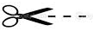
Print and cut out the cards
Give one set to each pair or group of students.
Students should match up the cards to make a chain, beginning with the ‘Start’ card, and working towards the ‘Finish’ card. All cards are used.
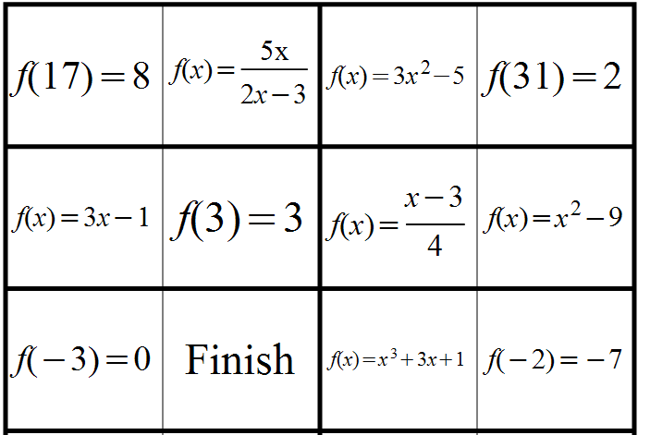
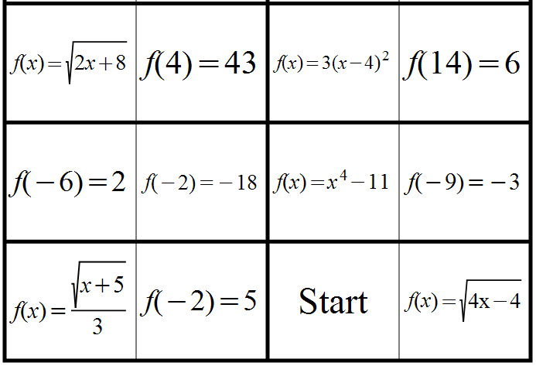

Problem solving 2: Composite Functions
Print and cut out the cards
Give one set to each pair or group of students.
Students should match up individual cards to make pairs. Two of the cards do not have a pair - students should use the two spare cards provided to create a pair for each of these two cards.
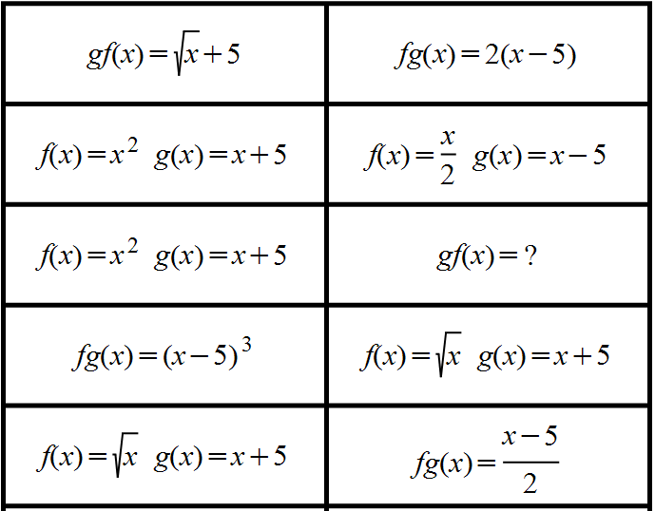
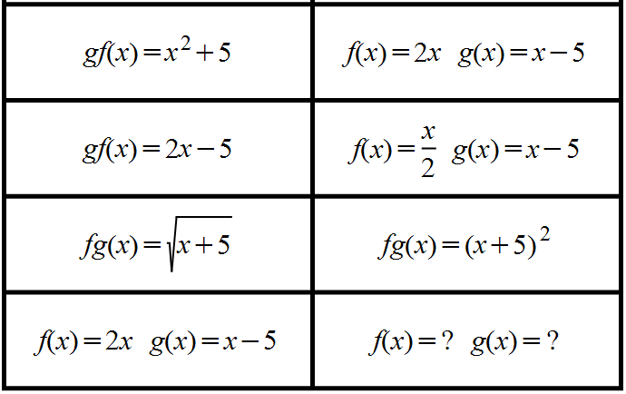
Answers

 | Skills builder 1: Functions
 | 1 | A = 15, B = −17, C = +6, D = ÷(−45)

 | 2 | Any five correct rules, for example:  - +15  - ×2, +5  - ×3, −5  - square, ÷4  - ×5, ÷2 etc.

 | 3 | (a) The output is 289.  (b) The inverse operations (from right to left) are:  - square root  - −2  - ÷5

 | 4 | Multiplying by ‘a’ followed by adding ‘b’ would have a function of the form ax + b.  When x = 7 the output is 60, so 7a + b = 60.  When x = 14 the output is 25, so 14a + b = 25.  Solving these equations simultaneously or through trial and improvement gives  a = −5 and b = 95.  Therefore Molly’s rule is multiplying by −5 and adding 95

Skills builder 2: Function Notation

 | 1 | (a) f(x) = 2(x + 4)  (b) f(x) = 2x + 4  (c) f(x) = 3x2  (d) f(x) = (x − 5)2  (e) f(x) = x2 − 5  (f) f(x) = 5x3 + 2  (g) f(x) = $\sqrt{x}$ − 9  (h) f(x) = $\sqrt{x − 9}$

 | 2 | (a) f means square the number, multiply by three and add one.  g means subtract five and then cube the answer.  (b) Calculate  (i) f(6) = 109  (ii) g(6) = 1  (iii) f(−4) = 49  (iv) g(−2) = −343  (c) g(3) = (3 – 5)3 = −8. Jamil has done the operations the wrong way around.  He has cubed 3 to get 27 and then subtracted 5 to get 22

 | 3 | (a) f(x) = $\frac{x}{9}$ + 7  (b) inverse f −1(x) = 9(x − 7)

 | 4 | (a) f(x) = 2(x + 5) − 1  (b) inverse f −1(x) = $\frac{x + 1}{2}$ − 5

Skills builder 3: Composite Functions

 | 1 | (a) f followed by g = (x − 5)3  (b) g followed by f = x3 − 5  (c) h followed by g = (3x)3 or 27x3  (d) g followed by h = 3x3  (e) f followed by h = 3(x − 5)  (f) h followed by f = 3x − 5

 | 2 | (a) f(x) = $\sqrt{x}$ and g(x) = x + 2 and the composite is f followed by g  (b) f(x) = x2 and g(x) = $\frac{x}{7}$ and the composite is f followed by g  (c) f(x) = x + 2 and g(x) = x4 and the composite is f followed by g

 | 3 | f followed by g is (x − 5)3 and then applying function h given 3(x − 5)3

 | 4 | f(x) = 2x, g(x) is x + 1 and h(x) =$\sqrt{x}$ and the composite is f followed by g then followed by h

Problem Solving 1: Function Notation
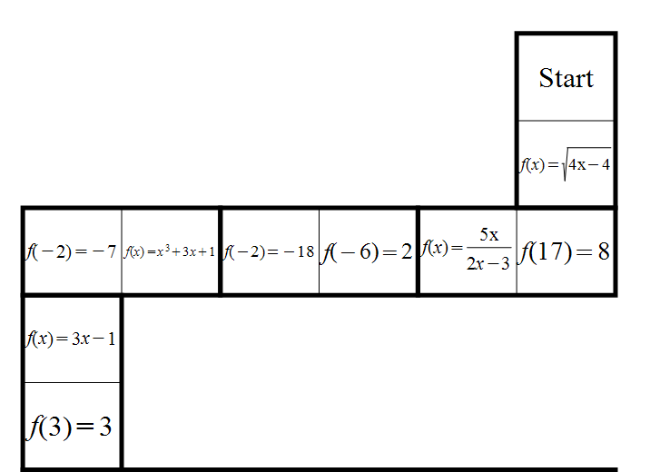
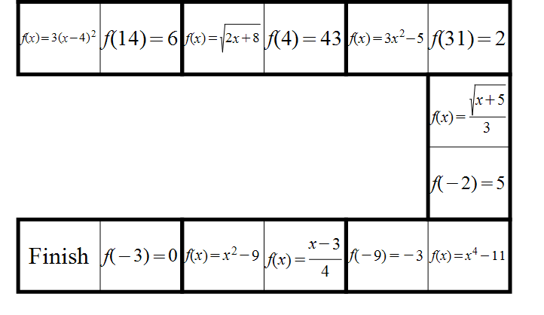

Problem Solving 2: Composite Notation
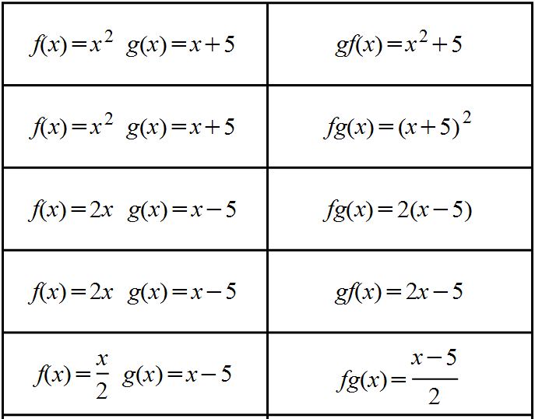
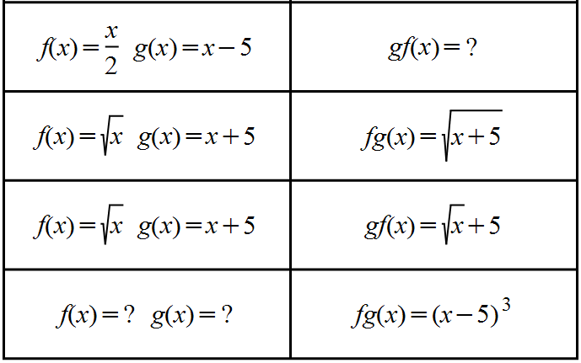
The missing cards are gf(x) = $\frac{x}{2}$ − 5 and f(x) = x3, g(x) = x − 5

